BLACKHEATH & BROMLEY HARRIERS AC

150th Anniversary Dinner at the House of Commons
Thursday 7 November 2019

Our 150th Anniversary Dinner is now fully booked, 152 have paid the required deposit and a there will be a further 18 formal guests at the dinner making 170 in all. It is possible that places will become available if one or two do not take up their reserved options. If you have missed this opportunity and wish to go on the waiting list for a place then please pay the deposit and notify Chris Haines accordingly.

The dinner, by courtesy of Colonel Bob Stewart DSO MP, will be in the Members Dining Room and is ‘black tie preferred’. The timings are such that the reception will start at 1830 and carriages should be arranged for about 2225, you will also need to allow plenty of time to get to the House of Commons and to pass through security. It would be sensible to plan your arrival at least for 1730.

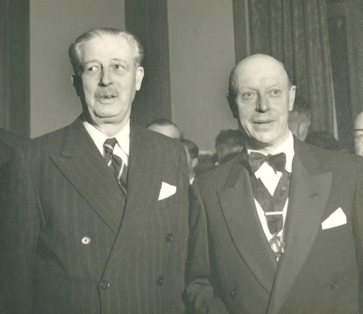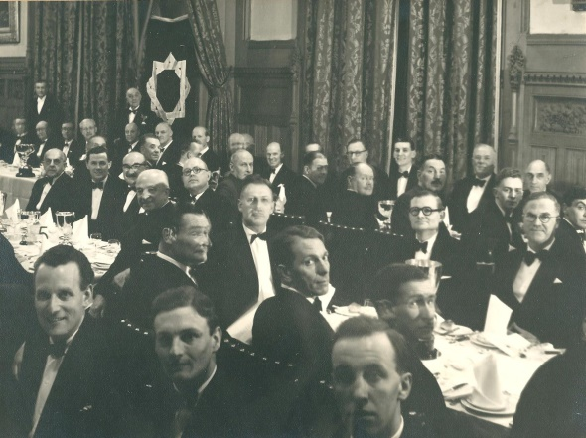
PM Harold Macmillan with PP Victor Beardon Members Dining Room 6th February 1959
The balance on your place(s) is payable by 31 August 2019. Please also indicate any dietary requirements that you have in relation to the dinner. Further details and formal invitations will be sent out in September.

PP Chris Haines
tel: 020 8777 6498, email: c.r.haines@city.ac.uk

1. | Name:
 | Dietary requirements: YES/NO
 | If YES give details:
 | :
2. | Name:
 | Dietary requirements: YES/NO
 | If YES give details
Cheques (£80 balance per person, £20 deposit per person for the waiting list) made payable to
“Blackheath & Bromley Harriers AC” should be sent to :
Prof C R Haines, 15 The Glade, West Wickham, Kent BR4 9LH.
The details for bank transfer payments to Blackheath & Bromley Harriers AC are:
Sort Code: 40-11-60 (HSBC) Account number: 50788104 Reference: <your name> 150 Dinner
Please advise by e-mail to c.r.haines@city.ac.uk if paying in this way, giving dietary requirements as above and including the amount and the date of payment.

