**Background**

easyfundraising.org.uk is a great way to **raise money** for charities, schools, **sports clubs**, community groups, and other good causes just by shopping online. You don’t pay anything extra. So far they’ve raised over £5 million for causes throughout the UK.

BBHAC is registered with easyfundraising.org.uk and so far has raised around £500 without promoting this facility. This is voluntary, requires no fees and little effort in order to raise “free” money for the Club.

**How does it work?**

* When you do your online shopping and use a Retailer who participates in the scheme you will earn money for BBHAC for each purchase you make, typically between 0.75 & 2.5%!
* Check here for more details: - <http://www.easyfundraising.org.uk/how-it-works/>

**Example - we raised £3.16 from buying a washing machine**

Many Many well-known Retailers participate

* Examples are Next, Amazon, Boden, Game, Play.com, Tesco Direct
  + <http://www.easyfundraising.org.uk/retailers/>

**Joining EasyFunding (there are two options)**

1. Create an account and log in to EasyFundraising using this address - <http://www.easyfundraising.org.uk/panel/> and follow the instructions:
   1. Click ‘I want to support a good cause’.
   2. Search ‘Blackheath & Bromley Harriers AC’ and click to support this cause.
   3. Complete the sign up section by entering the relevant details
   4. We suggest you use the option to implement a webpage tool – this means the website browser will identify that you are using a registered Retailer: Click the ‘Install Find & Remind’ button or visit this page: <http://www.easyfundraising.org.uk/raise-more/find-and-remind/> - The process is described in the following page.
2. Email [jon.pairman@googlemail.com](mailto:jon.pairman@googlemail.com) and we will invite you to become a member
   1. An advantage of this method is that easyfundraising will add a £5 donation once you have raised £10 for BBHAC!

**Objectives**

We are targeting to raise £500 for the club in the next 6 months, but believe there is no reason why this figure could not be many times this once members get used to the procedure. Monthly updates will be made on the club website.

C:\Program Files\Microsoft Office\MEDIA\CAGCAT10\j0183290.wmf 

**Shopping Online for Christmas? Raise “easy” funds for BBHAC**

**Easyfunding Toolbar**

Click on “Install the toolbar”

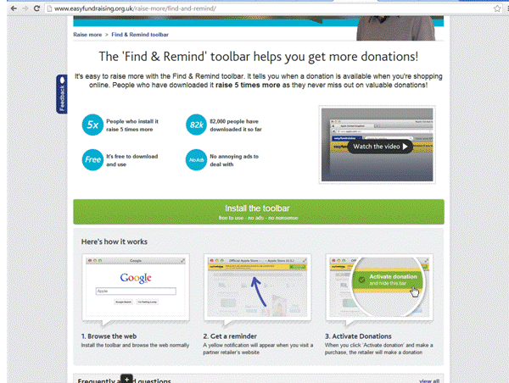

You may be asked to approve this

“EF” will appear in your tool bar

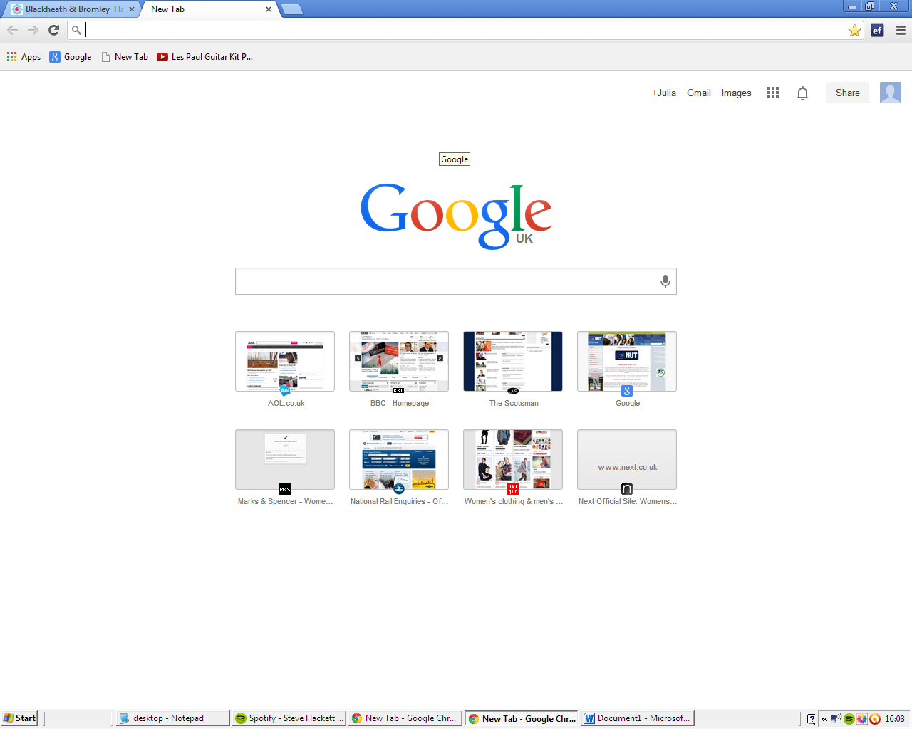

When you go to a Retailer’s website that is participating in the arrangement, you will usually see a yellow bar

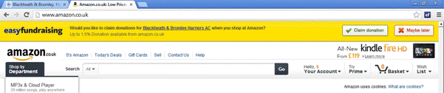

Click on claim donation

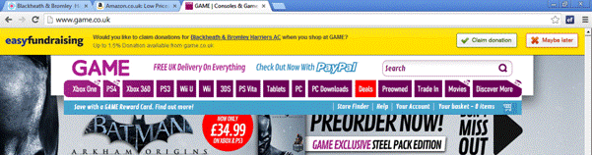

Website confirms funds will be raised!

